Engineering Mechanics
Chapter
10
Introduction text here... Engineering Mechanics package solve general engineering problems such as moment-curvature, biaxial analysis, torsional analysis of an arbitrary section, etc.

Reinforced Concrete Section Analysis
The reinforced concrete section analysis service provides analytical models that can be used to study the behavior and compute the attributes of a reinforced concrete section.

Requirements
The reinforced concrete section analysis service must solve the biaxial analysis problem for reinforced and prestressed concrete sections using an equivalent pressure method.

Logical Design
The design of this service is modeled after Algorithmic Objects, C++ Report, Vol. 9, No. 6, June 1997. A reinforced concrete section analysis problem is modeled with a problem representation object called rcaCapacityProblem. A rcaCapacitySolver object is used to solve the problem and products a rcaCapacitySolution object.

Static Models
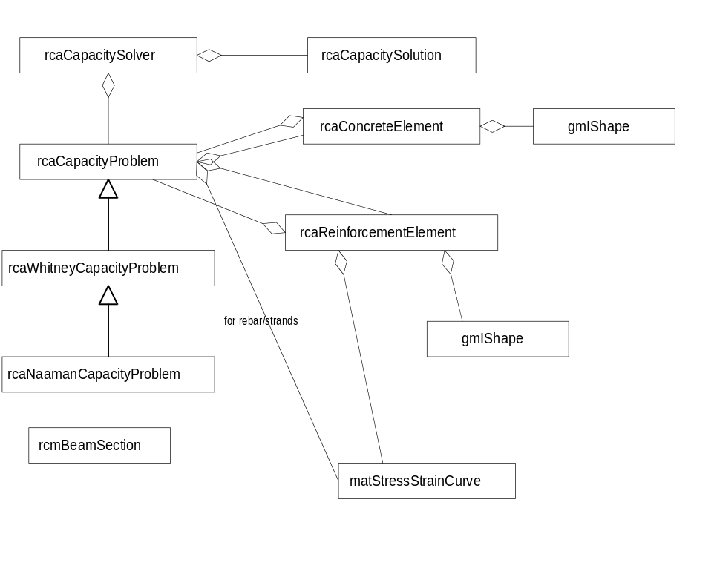

Dynamic Models
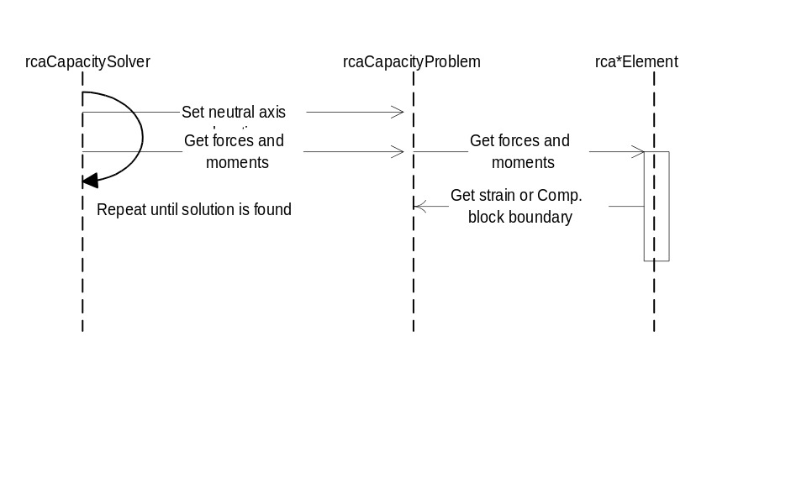

Physical Design

Specifications
RcBeam product model in separate doc.

rcaCapacityProblem
Abstract base class for concrete section capacity problems using a uniform stress block approach. This class is subclassed for the Whitney and Naaman analysis methods.

Public Interface - Member Functions
rcaCapacityProblem
rcaCapacityProblem();
Constructor. Sets the maximum compressive concrete strain to -0.003 and creates a “standard” 28Mpa (4ksi) concrete.
rcaCapacityProblem
rcaCapacityProblem(const rcaCapacityProblem& rOther);
Copy constructor.
operator=
rcaCapacityProblem& operator=(const rcaCapacityProblem& rOther);
Assignment operator.
SetConcrete
void SetConcrete(const matConcrete& concrete);
Sets the base concrete material for the problem.
GetConcrete
const matConcrete& GetConcrete();
Returns the base concrete material for the problem.
AddMildSteel
Int32 AddMildSteel(const matMetal& steel);
Adds a mild steel material to the problem. Calls DoCreateMildSteelMaterialModel() to create the stress strain curve and then stores the material model in a library. Returns a key which can be used to identify this material when creating elements.
AddStrand
Int32 AddStrand(const matPsStrand& strand);
Adds a strand material to the problem. Calls DoCreateStrandMaterialModel() to create the stress strain curve and then stores the material model in a library. Returns a key which can be used to identify this material when creating elements.
RemoveMaterial
bool RemoveMaterial(Int32 id);
Removes a material (concrete, mild steel, or strand) from the problem. Returns true if the material was successfully removed, otherwise false.
MildSteelMaterialCount
Int32 MildSteelMaterialCount() const;
Returns the number of mild steel materials in the problem.
StrandMaterialCount
Int32 StrandMaterialCount() const;
Returns the number of strand materials in the problem.
MaterialCount
Int32 MaterialCount() const;
Returns the total number of materials in the problem.
AddConcreteElement
Int32 AddConcreteElement(const gmIShape& shape,Float64 nFactor);
Adds a concrete element in the problem. Returns a key which can be used to identify this element. The nFactor may be used to modify the strength of this element relative to the base concrete material.
AddReinforcementElement
Int32 AddReinforcementElement(const gmIShape& shape, Int32 matId, Float64 initStrain = 0.);
Adds a reinforcement element in the problem. Returns a key which can be used to identify this element. Throws a rcaXRcCapProbError exception, with reason code MaterialNotFound, if the element could not be created. The initial strain should be equal to the difference between the strain in the concrete and the strain in the rebar element after losses have occurred.
RemoveElement
bool DestroyElement(Int32 id);
Removes an element from the problem. Returns true if the element was successfully removed, otherwise false.
ConcreteElementCount
Int32 ConcreteElementCount() const;
Returns the number of concrete elements in the problem.
ReinforcementElementCount
Int32 ReinforcementElementCount() const;
Returns the number of reinforcement elements in the problem.
ElementCount
Int32 ElementCount() const;
Returns the total number of elements in the problem.
SetMaxCompressiveStrain
void SetMaxCompressiveStrain(Float64 strain);
Sets the maximum compressive strain at the farthest concrete compressive fiber in the section. This value is -0.003 by default.
GetMaxCompressiveStrain
Float64 GetMaxCompressiveStrain() const;
Returns the maximum compressive strain at the farthest concrete compressive fiber in the section.
SetNeutralAxisLocation
void SetNeutralAxisLocation(const gpLine2d& line);
Sets the location and orientation of the neutral axis. The compression side is always on the left side of the line.
GetNeutralAxisLocation
void GetNeutralAxisLocation(gpLine2d* line) const;
Retrieves the location and orientation of the neutral axis.
GetCompressionBlockBoundary
Float64 GetCompressionBlockBoundary() const;
void GetCompressionBlockBoundary(gpLine2d* line) const;
Gets the location of the compression block boundary. The first form returns the location of the compression block boundary as an offset from the neutral axis. The second form returns two points on the compression block boundary line. The compression block is to the left of the boundary line.
GetStrain
Float64 GetStrain( const gpPoint2d& p ) const;
Float64 GetStrain( Float64 x, Float64 y) const;
Float64 GetStrain( Int32 elId ) const;
Returns the strain at the given point. In the third form, the strain at the centroid of the element identified by elId is returned. If the specified element could not be found, a rcaXRcCapProbError exception, with reason code ElementNotFound, will be thrown.
GetSectionForces
void GetSectionForces(Float64* pFx,
Float64* pMy,
Float64* pMz) const;
Returns the axial force and moments, with respect to the plastic centroid, on the section for its current neutral axis position. A rcaXRcCapProbError exception, with reason code InvalidModel, will be thrown if the section forces can not be determined.
GetSectionForcesEx
void GetSectionForcesEx(Float64* pFz,
Float64* pMx,
Float64* pMy,
Float64* compRes, gpPoint2d* compLoc,
Float64* tensRes, gpPoint2d* tensLoc) const;
Returns the axial force and moments, with respect to the plastic centroid, on the section for its current neutral axis position. Also returns the magnitudes and locations of the compression and tensile force resultants. A rcaXRcCapProbError exception, with reason code InvalidModel, will be thrown if the section forces can not be determined.
GetTensileCapacity()
Float64 GetTensileCapacity() const;
Returns the ultimate tensile axial force which can be applied to the section. This capacity is determined by applying a uniform tensile strain equal to the smallest ultimate tensile strain of all reinforcement materials which make up the problem model. A rcaXRcCapProbError exception, with reason code InvalidModel, will be thrown if the tensile capacity can not be determined.
GetClippedConcreteArea
Float64 GetClippedConcreteArea(const gpLine2d& clipLine, gpLine2d::Side) const;
Returns the area of concrete on the given side of the clipLine. This area is factored by the N factor(s) of all concrete elements.
GetCompressiveCapacity()
Float64 GetCompressiveCapacity() const;
Returns the ultimate Compressive axial force which can be applied to the section. This capacity is determined by applying a uniform Compressive strain equal to .003 to the model. A rcaXRcCapProbError exception, with reason code InvalidModel, will be thrown if the compressive capacity can not be determined.
Both capacities must be known in order to bound the interaction diagram
GetPlasticCentroid
gpPoint2d GetPlasticCentroid() const;
Returns the location of the plastic centroid (defined as the center of force when a uniform compressive strain of 0.003 is applied to the model). A rcaXRcCapProbError exception, with reason code InvalidModel, will be thrown if the plastic centroid can not be determined.
GetBoundingBox
gpRect2d GetBoundingBox() const;
Returns the bounding box of the problem.
Draw
void Draw(HDC hDC, const sysPointMapper& mapper) const;
Draws the problem on the given device context using the given mapper.

Protected Interface - Member Functions

This method is not needed in the protected interface. Subclasses should not have any control over how the compression block boundary is stored. Their only job is to compute it and possible access it.
DoCalculateCompressionBlockBoundary
virtual Float64 DoCalculateCompressionBlockBoundary()=0;
Pure abstract function to calculate the location of the compression block boundary. Implement this function to determine the compression block location for the Whitney or Naaman approach. Returns the offset measured normal to the neutral axis line.
OnNeutralAxisChanged
virtual void OnNeutralAxisChanged();
Called by SetNeutralAxisLocation() when ever the neutral axis changes. This method calls DoCalculateCompressionBlockBoundary().
DoCreateMildSteelMaterialModel
virtual matStressStrainCurve* DoCreateMildSteelMaterialModel(const matMetal& steel);
Called by AddMildSteel() when a steel material is added to the problem. This is a factory method that creates a stress strain curve for mild steel. The default behavior of this method is to create a matBilinearCurve material model.
DoCreateStrandMaterialModel
virtual matStressStrainCurve* DoCreateStrandMaterialModel(const matPsStrand& strand);
Called by AddStrand() when a strand material is added to the problem. This is a factory method that creates a stress strain curve for prestress strands. The default behavior of this method is to create a matPsStrandCurve material model.

rcaWhitneyCapacityProblem
Derived from rcaCapacityProblem, this class computes the forces in a concrete section using the Whitney method.

Public Interface - Member Functions
rcaWhitneyCapacityProblem
rcaWhitneyCapacityProblem();
Constructor.
rcaWhitneyCapacityProblem
rcaWhitneyCapacityProblem(const rcaWhitneyCapacityProblem& rOther);
Copy constructor.
operator=
rcaWhitneyCapacityProblem& operator=(const rcaWhitneyCapacityProblem& rOther);
Assignment operator.

Protected Interface - Member Functions
DoCalculateCompressionBlockBoundary
virtual Float64 DoCalculateCompressionBlockBoundary();
Overrides the pure virtual function. Calculates the compression block boundary such that the distance from the compression block boundary to the farthest compressive point from the neutral axis is equal to Beta1 times the distance from the neutral axis to the farthest compressive point.
DoCreateMildSteelMaterialModel
virtual matStressStrainCurve* DoCreateMildSteelMaterialModel(const matMetal& steel);
Overrides the base class implementation and creates a matLinearCurve material model whose failure stains for tension and compression are +/-DBL_MAX, respectively. The second curve of the bilinear curve is horizontal. Use these extremely large failure strains results in an infinitely plastic material behavior.
DoCreateStrandMaterialModel
virtual matStressStrainCurve* DoCreateStrandMaterialModel(const matPsStrand& strand);
Overrides the base class implementation and creates a matPlasticPsStrandCurve. This material model exhibits the same behavior as the matPsStrandCurve, except when the strains exceed the fracture strain, the ultimate stress is returned. This provides a good approximation of infinitely plastic behavior.

rcaNaamanCapacityProblem
Derived from rcaWhitneyCapacityProblem, this class modifies the Whitney implementation to accommodate the changes described by Naaman. The changes amount to the location of the compression block boundary.

Public Interface - Member Functions
rcaNaamanCapacityProblem
rcaNaamanCapacityProblem();
Constructor.
rcaNaamanCapacityProblem
rcaNaamanCapacityProblem(const rcaNaamanCapacityProblem& rOther);
Copy constructor.
operator=
rcaNaamanCapacityProblem& operator=(const rcaNaamanCapacityProblem& rOther);
Assignment operator.

Protected Interface - Member Functions
DoCalculateCompressionBlockBoundary
virtual Float64 DoCalculateCompressionBlockBoundary();
Overrides the pure virtual function. Calculates the compression block boundary such that the area of concrete inside the compression block boundary is equal to Beta1 times the area above the neutral axis.

rcarcaCapacitySolver
This class solves the concrete capacity problem by performing a biaxial analysis.

Public Interface - Member Functions
rcaCapacitySolver
rcaCapacitySolver();
Constructor. Sets the applied axial force to zero, sets the moment interaction angle to zero, and sets the initial guess for the neutral axis to the mid-depth of the section, normal to the moment interaction line.
rcaCapacitySolver
rcaCapacitySolver(const rcaCapacitySolver& rOther);
Copy constructor.
operator=
rcaCapacitySolver& operator=(const rcaCapacitySolver& rOther);
Assignment operator.
SetAxialForce
void SetAxialForce(Float64 f);
Sets the applied axial force to be solved for.
GetAxialForce
Float64 GetAxialForce() const;
Returns the applied axial force.
SetMomentInteractionAngle
void SetMomentInteractionAngle(Float64 angle);
Sets the moment interaction angle. The moment interaction angle is the arctangent of My/Mx. A moment interaction angle is used because its range is between ±π/2 where the actual My/Mx ratio is between ±infinity. The moment interaction angle is measured clockwise in radians from the positive X axis.
GetMomentInteractionAngle
Float64 GetMomentInteractionAngle() const;
Returns the moment interaction angle.
SetNeutralAxisGuess
void SetNeutralAxisGuess(const gpLine2d& line);
Sets the initial guess of the location of the neutral axis
GetNeutralAxisGuess
void GetNeutralAxisGuess(gpLine2d* line) const;
Retrieves the initial guess for the neutral axis.
SetMaxIter
void SetMaxIter(Int32 maxIter);
Sets the maximum number of iterations before the solver fails. The default value is 500.
GetMaxIter
Int32 GetMaxIter() const;
Returns the maximum number of iterations before the solver fails.
SetAngleTolerance
void SetAngleTolerance(Float 64 tol);
Sets the solution tolerance for the moment interaction angle. The default value is 1.0e-4.
GetAngleTolerance
Float64 GetAngleTolerance() const;
Returns the tolerance.
SetAxialForceTolerance
void SetAngleTolerance(Float 64 tol);
Sets the solution tolerance for axial force. This value is not the tolerance for the real axial force per se. It is the tolerance for the distance D during the iteration, which is the distance from the plastic centroid to the neutral axis. The default value is 1.0e-5.
GetAxialForceTolerance
Float64 GetAxialForceTolerance() const;
Returns the tolerance.
Solve
rcaCapacitySolution Solve(rcaCapacityProblem& problem) const;
Solves the capacity problems and returns a solution object. Throws a rcaXCapacitySolverError exception if a solution could not be found.
If strict const rules were followed, this function would take a const reference to the CapacityProblem. However, the solver needs to set the neutral axis of the problem in order to do its job. Hence… non const. A good way to get around this would be to give CapacityProblem a solver-specific interface that would not allow the solver to change things it need not.

Implementation Notes
If the problem throws an rcaRcModelingError exception, with reason code InvalidModel, throw a rcaCapacitySolverError with reason code ModelingError.

rcaCapacitySolution
This class encapsulates the solution the reinforced concrete capacity problem.

Public Interface - Member Functions
rcaCapacitySolution
rcaCapacitySolution(Float64 P,
Float64 Mx,
Float64 My,
Float64 beta1,
const gpLine2d& naLine,
Float64 compFiberDist,
Float64 compBlockOffset,
Float64 areaAboveNeutralAxis,
Float64 compBlockArea,
Float64 compRes, const gpPoint2d& compResLoc,
Float64 tensRes, const gpPoint2d& tensResLoc)
Constructor.
rcaCapacitySolution
rcaCapacitySolution(const rcaCapacitySolution& rOther);
Copy constructor.
operator =
rcaCapacitySolution& operator=(const rcaCapacitySolution& rOther);
Assignment operator.
GetNeutralAxis
void GetNeutralAxis(gpLine2d* line) const;
Retreives the position of the neutral axis.
GetCompressionBlockBoundary
Float64 GetCompressionBlockBoundary() const;
void GetCompressionBlockBoundary(gpLine2d* line);
Gets the location of the compression block boundary. The first form returns the location of the compression block boundary as an offset from the neutral axis. The second form returns two points on the compression block boundary line.
GetAxialForce
Float64 GetAxialForce() const;
Returns the resultant axial force.
GetMx
Float64 GetMx() const;
Returns the moment capacity for bending about the x axis.
GetMy
Float64 GetMy() const;
Returns the moment capacity for bending about the y axis.
GetBeta1
Float64 GetBeta1() const;
Retreives Beta1 for the rcaCapacityModel associated with this solution.
GetAreaAboveNeutralAxis
Float64 GetAreaAboveNeutralAxis() const;
Retreives the area of concrete above the neutral axis.
GetCompressionBlockArea
Float64 GetCompressionBlockArea() const;
Retreives the area of the concrete compression block.
GetCompressionBlockDepth
Float64 GetCompressionBlockDepth() const;
Returns the depth of the compression block. The compression block depth is computed as the difference between the distance to the extreme fiber in compression and the compression block boundary.
GetCompFiberDistance
Float64 GetCompFiberDistance() const;
Returns the normal distance from the neutral axis to the extreme concrete compressive fiber.
GetForceRes
void GetForceRes(Float64* compRes, gpPoint2d* compResLoc,
Float64* tensRes, gpPoint2d* tensResLoc)const;
Returns the magnitudes of the compressive and tensile force resultants (compRes and tensRes), and their locations (compResLoc and tensResLoc, respectively).

rcaConcreteElement
Element in a rcaCapacityProblem.

Public Interface - Member Functions
rcaConcreteElement
rcaConcreteElement(const gmIShape& rShape, Float64 fc , Float64 nFactor, const rcaCapacityProblem& rProblem);
Constructor. Creates a concrete element with the shape rShape. The stress on the element, for any compressive strain is fc (this stress is 0.85f’_{c}). The area is factored by nFactor for force calculation. The element (or any part of it) is considered to be fully strained if it lies within the compression block boundary.
~rcaConcreteElement
~rcaConcreteElement();
Destructor.
SetProblem
void SetProblem(const rcaCapacityProblem& rProblem);
Associates this element with the capacity problem that it is a part of.
GetProblem
const rcaCapacityProblem& GetProblem() const;
CapacityProblem
Returns a reference to the capacity problem that this element is a part of.
GetForces
virtual void GetForces(Float64* pFz,
Float64* pMx,
Float64* pMy,
gpPoint2d* cg) const;
Computes the resultant local forces on this element and the point of application of the forces. Uses the compression block boundary to determine if the entire element is in compression. If not, the element is clipped to the compression block boundary.
GetShape
const gmIShape& GetShape() const;
Returns a reference to the element’s shape.
GetFc
Float64 GetFc() const;
Returns the concrete compressive strength associated with this element.
GetNFloat64 GetN() const;
material stGetClippedArea
li
Returns the clipped area of an element - the area is the shape area multiplied by the N factor.
GetBoundingBox
gpRect2d GetBoundingBox() const;
Returns the bounding box of the element.
Draw
void Draw(HDC hDC, const sysPointMapper& mapper) const;
Draws the element on the given device context using the given mapper.

rcaReinforcementElement
Element in a rcaCapacityProblem.

Public Interface - Member Functions
rcaReinforcementElement
rcaReinforcementElement(const gmIShape& shape, const matStressStrainCurve& rMaterialModel, const rcaCapacityProblem& rProblem, Float64 initStrain = 0);
Constructor.
~rcaReinforcementElement
virtual ~emReinforcementElement();
Destructor.
SetProblem
void SetProblem(const rcaCapacityProblem&* rProblem);
Associates this element with the capacity problem that it is a part of.
GetProblem
const rcaCapacityProblem& GetProblem() const;
CapacityProblem
Returns a reference to the capacity problem that this element is a part of.
GetForces
virtual void GetForces(Float64* pFz,
Float64* pMx,
Float64* pMy,
gpPoint2d* cg) const;
Computes the local forces on this element.
GetShape
const gmIShape& GetShape() const;
Returns a reference to the element’s shape.
GetInitialStrain
Float64 GetInitialStrain() const;
Returns the initial strain of the element.
GetStressStrainCurve
const matStressStrainCurve& GetStressStrainCurve() const;
Returns a reference to the stress strain curve associated with this element.
GetBoundingBox
gpRect2d GetBoundingBox() const;
Returns the bounding box of the element.
Draw
void Draw(HDC hDC, const sysPointMapper& mapper) const;
Draws the element on the given device context using the give mapper.

rcaXCapacitySolverError
Exception class for solver errors. Derived from sysXBase.

Public Interface - Member Functions
rcaXCapacitySolverError
rcaXCapacitySolverError(Reason reason, const char* file, Int16 line);
Constructor
rcaXCapacitySolverError
rcaXCapacitySolverError(const rcaXCapacitySolverError& rOther);
Copy constructor.
operator=
rcaXCapacitySolverError& operator=(const rcaXCapacitySolverError& rOther);
Assignment operator.
Throw
void Throw() const;
Implements the Throw() interface with:
void Throw() const
{ throw *static_cast<rcaXCapacitySolverError*>this; }
GetReasonCode
rcaXCapacitySolverError::Reason GetReasonCode() const;
Returns the reason the solver failed.
Can’t use enum if derived from sysXBase?
GetReason
Int32 GetReason() const;
Returns the reason the solver failed. Calls GetReasonCode() and casts the returned enum to an int.
GetErrorMessage
void GetErrorMessage(std::string* pMsg,Int32 reserved) const;
Overrides the standard error message with the error messages listed below
Reason | Message
ProblemRepError | There is an error with the analysis model
NoTensileCapacity | Analysis model has no tensile capacity
NoCompressiveCapacity | Analysis model has no compressive capacity
TensileCapacityExceeded | The applied axial load exceeds the tensile capacity of the model.
CompressiveCapacityExceeded | The applied axial load exceeds the compressive capacity of the model.
MaxIterExceeded | The maximum number of iterations have been exceeded.

Public Interface - Enumerations
Reason
enum Reason { ProblemRepError, // There is a problem w/ the problem
// representation
NoTensileCapacity, // Model has no tensile capacity
NoCompressiveCapacity, // Model has no compressive capacity
TensileCapacityExceeded, // Applied axial load was to large
CompressiveCapacityExceeded, // Applied axial load was to large
MaxIterExceeded, // Exceeded the maximum number of
// iterations
};
Reasons why the capacity solver failed.

rcaXRcCapProbError
Exception class for solver errors. Derived from sysXBase.

Public Interface - Member Functions
rcaXRcCapProbError
rcaXRcCapProbError(Reason reason, const char* file, Int16 line);
Constructor
rcaXRcCapProbError
rcaXRcCapProbError(const rcaXRcCapProbError& rOther);
Copy constructor.
operator=
rcaXRcCapProbError& operator=(const rcaXRcCapProbError& rOther);
Assignment operator.
Throw
void Throw() const;
Implements the Throw() interface with:
void Throw() const
{ throw *static_cast<rcaXRcCapProbError*>this; }
GetReasonCode
rcaXRcCapProbError::Reason GetReasonCode() const;
Returns the reason the solver failed.
GetReason
Int32 GetReason() const;
Returns the reason the solver failed.
GetErrorMessage
void GetErrorMessage(std::string* pMsg,Int32 reserved) const;
Overrides the standard error message with the error messages listed below
Reason | Message
MaterialNotFound | Material not found
ElementNotFound | Element not found
InvalidProblemRep | The problem representation is invalid

Public Interface - Enumerations
Reason
enum Reason { MaterialNotFound, // The specified material could not be found
ElementNotFound, // The specified element could not be found
InvalidProblemRep // The model is invalid
};
XRcCapProbError reason codes.

